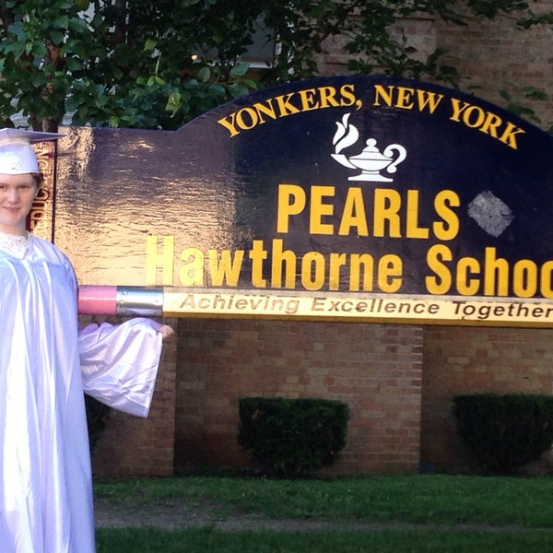

MINIMUM CAPACITY :-

The Minumum intake capacity

of students is between 300-620

children

LIBRARY :-

The Libarary is Available.

CANTEEN:-

The Canteen Facility is Available.

BOARDING :-

No availablility of boarding.

SPORTS :-

There are different categories

sports available.

Girls Volleyball

Boys Volleyball

Football

|  |  |  |
| --- | --- | --- |
| PEARLS HAWTHORNE SCHOOL  YONKERS - SCHOOL |  |  |
|  |  |  |
| School Detail :- The mission of PEARLS Hawthorne School is to provide a safe, nurturing, and holistic learning environment for our diverse population. We strive to cultivate metacognitive skills and encourage self-directed learning. We aim to support positive character traits and community consciousness. |  |